BMW Sales Analysis
1. Project Overview and Objective
This project involves cleaning, transforming, and analysing raw data using Excel and creating an interactive Power BI dashboard to derive meaningful business insights.
The main objective is to demonstrate data pre-processing techniques using Excel and an interactive Power BI dashboard visualization to make informed decisions.

2. Data Sources (Sample)
- Source Description and Timeline: BMW Sales analysis, Google Dataset Search and 2020-2024.
- Domain: Sales Analytics etc

3. Problem Statement (Sample)
- To analyse sales performance across regions and products to identify top-performing areas and profit trends.
- To understand customer purchasing behaviour to enhance marketing and retention strategies.
- Identifying top-performing vehicle models and understanding sales trends requires systematic data analysis.
- Regional sales performance varies across markets, making it difficult to determine high-growth and low-performing areas
4. Attribute (Column /Features) Details: (Sample)
Attribute Name | Data Type | Description
Model | Text/String | Name of the BMW vehicle model (e.g., X5, 3 Series, 5 Series).
Year | Integer | Manufacturing or sales year of the vehicle.
Region | Text/String | Geographic region where the vehicle was sold or recorded.
Colour | Text/String | Exterior colour of the vehicle.
Fuel Type | Text/String | Type of fuel used by the vehicle, such as Petrol, Diesel, Hybrid, or Electric.
Transmission | Text/String | Transmission type of the vehicle, such as Manual or Automatic.
Engine | Decimal Number | Engine capacity measured in litters (L).
Mileage | Whole Number | Total distance travelled by the vehicle, measured in kilometres.
Price | Currency/Decimal Number | Selling price of the vehicle in U.S. Dollars (USD).
Sales | Whole Number | Number of vehicles sold for a specific model, region, or period.

5. Tools & Technologies
- Excel: Data cleaning, transformation, and Pivot Tables.
- Power BI: Data modelling, DAX calculations, visualization, and interactive dashboard creation.

6. Data Pre-Processing (Excel / Power Query) (Sample)
Tasks Performed:
- Data Cleaning & Transformation: Removed duplicates, handled missing values, standardized formats, and created calculated fields.
- Filtering & Sorting: Organized data to focus on relevant records.
- Pivot Tables: Generated Pivot Tables for data summarisation and initial insights.
- Convert the data into Fact and Dimension Table (If Possible)

7. Data Modelling and DAX (Power BI)
- Data Model: Established relationships between tables, defined cardinality, and created lookup tables where necessary.
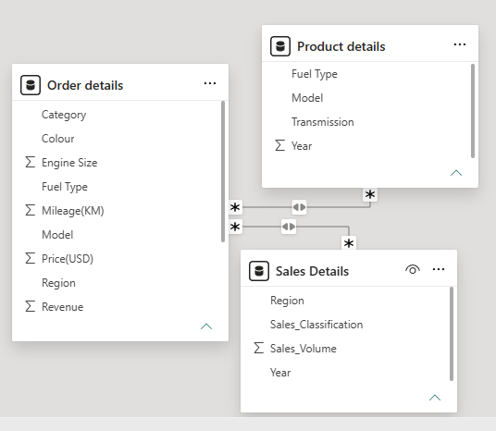
SCREENSHOT OF DATA MODELLING
- Calculated Columns & DAX Measures: Implemented DAX formulas for key metrics, such as total sales, growth percentages, and cumulative totals.
DAX Calculated Columns
- A calculated column was created by combining Fuel and Transmission to provide a more detailed product classification.
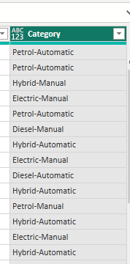

- A new column was created to calculate Revenue generated per order using the formula
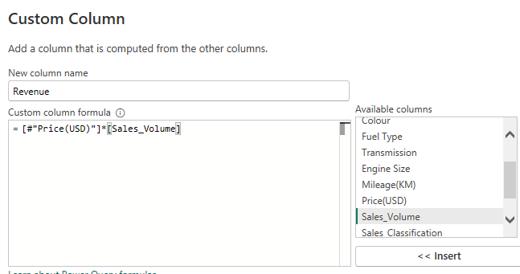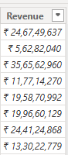

8. Analysis and Visualizations (Power BI)
Dashboard Features:
- Multiple Visualizations based on problem statement: Bar charts, line charts, pie charts, cards, and tables to communicate insights.
Yearly sales
A clustered column chart was used to compare actual Yearly sales across different region categories.
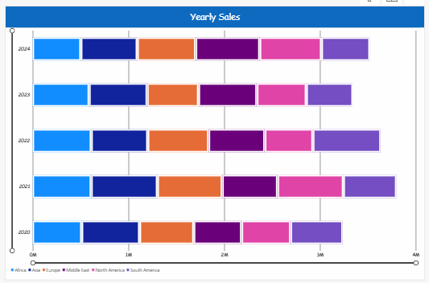
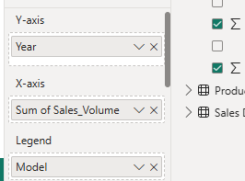
Region wise sales
A tree map visual displayed the contribution of different Region to total sales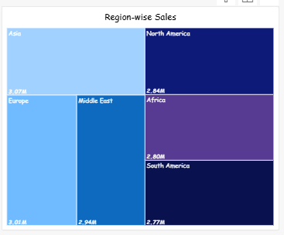 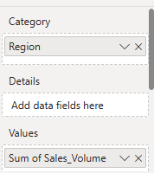
Order Count Analysis by State
A funnel chart illustrated the distribution of Sales across various Models.
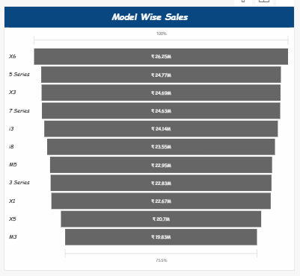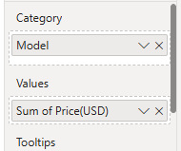

Mileage Analysis
A line chart displayed Models performance and highlighted overall sales trends over time.
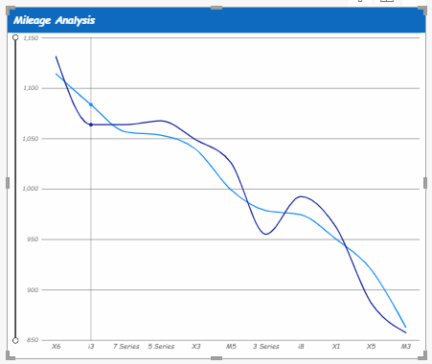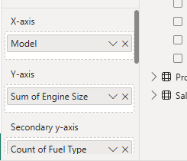

Sales Performance by Fuel type
A donut chart was created to identify Sales contributing the Fuel type

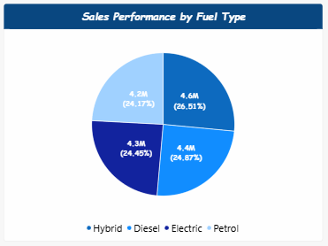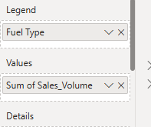
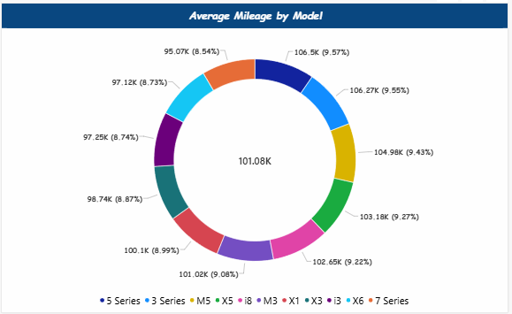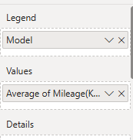
Customer colour preference
A scatter chart was used to examine the relationship between Customer choice for the colour and Models sold for different sub-categories.

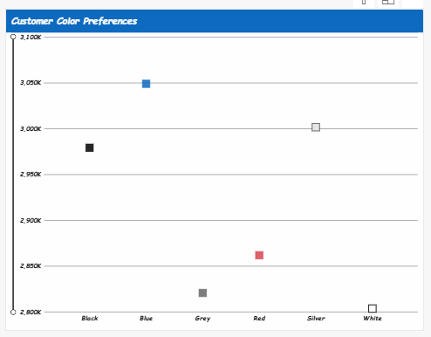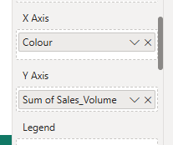

Sales Performance Matrix
A matrix visualization provided a detailed comparison of actual sales against by Models and month.
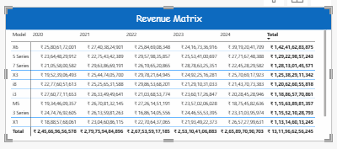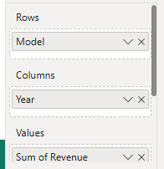
Revenue by year and model
A clustered column chart was used to compare actual Yearly sales across different product categories.
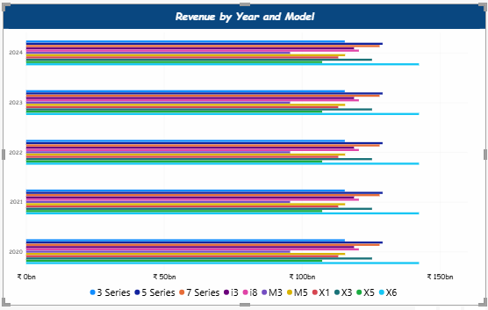
Revenue by Region
A Stacked column chart was used to compare actual Yearly sales across different Region categories.
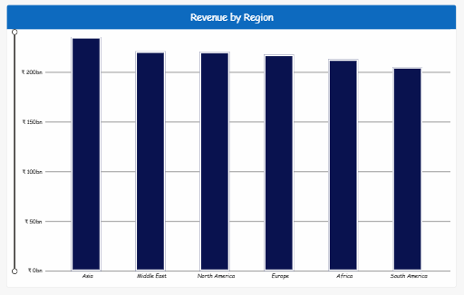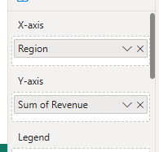
Mileage based Engine Reliability
An area chart was used to compare actual Engine reliability across different Engine categories.
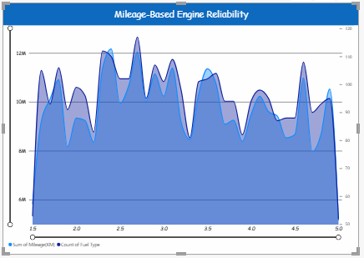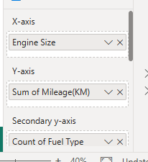
Dashboard
The final dashboard integrates all the above charts to provide Descriptive, Diagnostic, Predictive, and Prescriptive Analytics, enabling better decision-making and improving the sales and overall performance of the BMW brand.
Dashboard 1
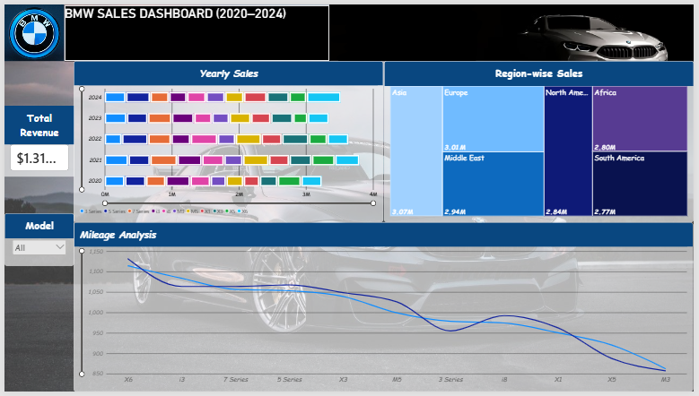

Dashboard 2
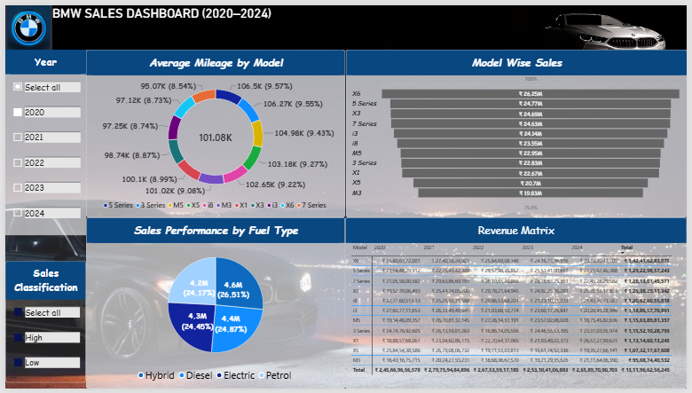

Dashboard 3
- 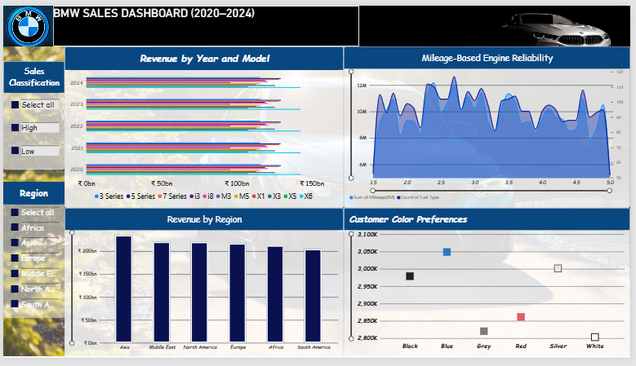

9. Insights & Conclusions
- Key Findings: Summarize trends, patterns, or anomalies identified in the data
- Provide the analysis insights:
- Descriptive
Summarises BMW sales data for 2010–2024 by year, model and region.
Compares sales and revenue across vehicle categories.
Displays fuel type, colour and mileage patterns through charts and matrices.
- Diagnosis
Compares models and regions to investigate differences in sales performance.
Examines fuel type, transmission, price and mileage alongside sales.
Highlights patterns for further investigation rather than proving their causes.
- Predictive
Historical sales trends could support estimates of future demand.
Model and regional patterns could inform potential sales forecasts.
No validated forecasting model or prediction results are documented in this report.
- Prescriptive
Use model and regional comparisons to guide inventory and marketing priorities.
Consider fuel type and colour sales patterns when planning the product mix.
Validate these recommendations against business targets and additional evidence before acting.

10. Conclusions (Sample)
The integration of Excel and Power BI proved effective for end-to-end data analysis, from raw data to visual reporting.

